Elastic File System (EFS)

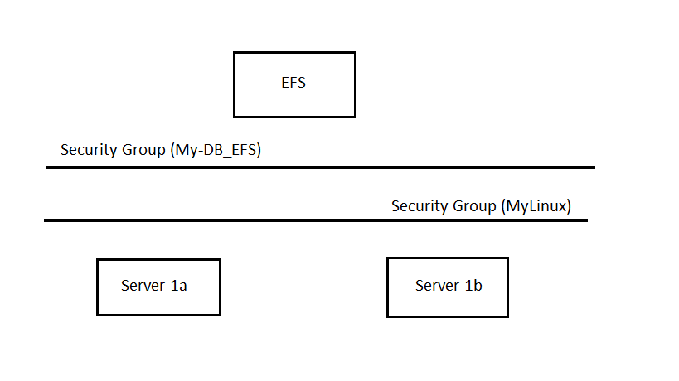

-Create EC2 instance with 1a AZ (ie server-1a)

-Security group (allow ssh & http) (ie MyLinuxSG)

-Create EC2 instance with 1b AZ (ie server-1b)

-Security group (allow ssh & http) (ie MyLinuxSG)

-Create new security group (My-DB-EFS)

-Inbound rules:

NFS – TCP – 2049 – custom – MyLinuxSG

-Search EFS Service

-Click on create file system

-Give name & click on customize

-Select Regional -> Enable automatic backups ->

-Throughput mode: select bursting

-Additional Setting: General purpose -> click next

-Choose security group My-DB-EFS for ap-south 1a, ap-south 1b, ap-south 1c

-click on next

-click on next

-click on create

-Connect two instances ie server 1a & server 1b with putty

-click on file system id -> attach -> learn more -> manually installing the amazon EFS client

-copy command to install the amazon – efs – utils package

-install amazon –efs – utils package on both EC2 instances

-Create mount point on both EC2 instances

Sudo mkdir /efs

-Attach EFS file system

- Select mount via dns

- Copy command & run on both instances

-Create file & add content in the file in one instance & check that file in another instance